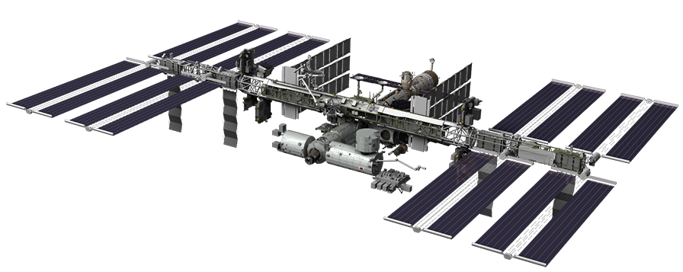
September Activities

We’re off and running! By now your group should have its experiment topic and hypothesis finalized. You should be establishing teams (e.g. science, hardware, software, communications, etc.) within your group that will be responsible for testing the subsystems of your experiment. This is crucial to the success of your project! Each of the teams should use a design matrix, as they brainstorm, to help them determine solutions (there are templates on the web site). Over the next two months, you should develop 2-4 block diagrams from these initial designs to present at the Preliminary Design Review (the first week of November). Another important task to get started on is your preliminary list of materials. You will add to this list over the next few months. Be sure to include the part, part number, description, and vendor. This material list will need to be turned in to NASA as part of the Safety Review, so please pay attention to detail. There is a template on the website to help you.

There are also PPT presentations on the website, from the technical training workshop, that can help guide you through the experiment design and implementation process that you can review and share with your students. You may also want to use an online planning tool, like Tom’s Planner (www.tomsplanner.com), a free online Gantt Chart planning program, to help with project management.

Other activities your group should complete in September include:

Team Webpage – http://spacestationndc.weebly.com
Each team has a webpage where assignments, blogs, photos, videos and anything you want to share about your project should be posted. Content should be posted weekly during the school year that outlines your team’s activities and progress. This a great job for the Communications Team.

Posts that are due by September 30, 2015 include:
  - Weekly entries: 1-2 paragraphs describing what your team did that week; include photos or videos of students working (include captions); you may want to video tape interviews with the student team leads
  - Project Management: List the teams and the subsystems they will be responsible for, (e.g. science, hardware, software, communications, budget/materials acquisition, etc.) as well as the tasks for each one.
  - Experiment Research: You’ve already completed some preliminary research on your topic. Assign a team (e.g. science team) to do more detailed research and become the experts in that topic. Post a summary of any additional research – be sure to look at past design ideas (either Earth or space-based). Also, conduct research on different kinds of materials that could be used to secure your experiment (without harming your biologics, if you have any in your experiment). The more you research, the better your experiment!
  - Concept Design:
  - Written description of the design ideas
  - Sketches (hand or computer drawn) with labels
  - Decision Matrices
  - Drawings from students’ engineering notebooks and brainstorming notes

Set-up Engineering Notebooks – Refer to the website for the Engineering Notebook PPT presentation, Example Notebook, and Footers handout.

Establish weekly Zoom conference calls with Texas A&M team
This is a brief tag up between the Texas A&M Project Lead and your student Team Leads. Adult Leads may attend as well.

There is a Hardware Orientation and Software Orientation video on the Texas A&M Wiki that you can watch to help reinforce what you learned at the Technical Workshop. Please share it with the individuals who could not attend the training session to help them understand the NESI+.

Establish bi-weekly Zoom conferences with CASIS Ops team
This is a brief tag up (15 – 30 mins) with the Adult Team Leader and your CASIS Operations Manager to go over the status of your project and to answer any questions you may have.

Mission Patch
Begin designing a mission patch for your experiment. For every space flight, the astronaut crew designs its mission patch. Included in the patch design are various elements that describe the mission and the names of the astronauts. If you decide to make patches or stickers from your design, CASIS will fly approximately 20-25 of them to the ISS! You and your team can check out some of the different mission patches from previous missions on this NASA website -
http://www.nasa.gov/offices/education/programs/national/dln/events/Mission_Patch_Design.html#.VcixAJ1VhBc.

Fun and Educational Demonstrations on the ISS
Saturday Morning Science Videos – Astronaut Don Petit does fun experiments of his own on the ISS.
http://www.spaceflight.nasa.gov/station/crew/exp6/spacechronicles.html

Wringing Out Water on the ISS – for Science! – Astronaut Chris Hadfield performs a science demonstration using a washcloth and water.
https://www.youtube.com/watch?v=o8TssbmY-GM
CASIS Publication Database – Searchable database to recently published research conducted onboard the ISS.
http://www.spacestationresearch.com/research-library/published-articles/

