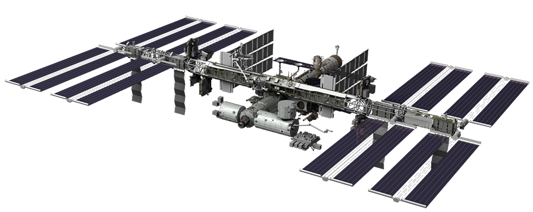
October Activities

Greetings!

This is a busy month! Your team should be conducting ground testing and developing design concepts for the flight experiment. It’s very important to write procedures for your incremental (subsystem) testing that should include data collection of your subsystems and specific step-by-step procedures for each subsystem (e.g. engineering team is testing sensors). Your team should be developing: 1) design matrices to help you brainstorm and determine solutions; 2) block diagrams of the designs that you are considering for your experiment; and 3) preliminary list of materials.

2. Everyone should be preparing for the Preliminary Design Review that will take place during the first week in November via a Zoom Conference. The purpose of this Review is to share 2-3 preliminary experiment designs with your CASIS Operations Manager and the Texas A&M and NanoRacks support teams. By the end of the meeting, you should have a clear idea of what your final prototype will be. From that point forward, your team will strive to create, test and polish this final prototype in preparation for the Critical Design Review that will be held in the first week of February. Remember, a pitfall in design is not documenting your changes. As you move forward on your design(s) and testing, any real time changes must be documented in your engineering notebooks.

In preparation for the PDR, you may want to assign the task of creating a 10-15-minute PowerPoint presentation to the Communication team his month. Additionally, select 1-2 youth leads to give the presentation at the PDR. They should be prepared to talk about the progress the team has made, and any questions or concerns they may have for CASIS, Texas A&M and NanoRacks about designing their experiments. Much of the content for this presentation should be pulled directly from your team’s webpage (if you’ve kept up with it!).

Your presentation should include the following items:

Slide 1: Project name, team name, Council name (include a group photo – youth, adult facilitators, and mentors)
Slide 2: Description and hypothesis of your experiment
Slide 3 - 5: Photos of brainstorming notes, design matrices, mission patch (or patch design ideas)
Slide 6: Project Management – description of the subsystems, procedures for incremental testing; sub-team photos
Slide 7-8: Diagrams of 2-3 conceptual designs (can be sketches from engineering notebooks or computer drawings; If you have actual prototypes to share at the PDR, even better!)
Slide 9: Conceptual Block Diagram
Slide 10: Functional Diagram (draft version is good at this point in time)
Slide 11: Storyboard (draft version of this one, too)
Slide 12: Preliminary list of materials (can be a photo of the material list taken from an engineering notebook)

2. Submit t-shirt sizes of the youth, adult facilitators, and mentors on your team. CASIS will provide t-shirts for all members of the core team. Please use the roster that was provided to you via email. You should receive your t-shirts sometime in November.

3. Team Webpage – Communication group should be uploading posts on a weekly basis during the school year that outlines your team’s activities and progress.

